Spearman rank correlation: EURUSD and NZDUSD
Method 02 / daily log returns / Alpari D1 full available history

Study setup
Logical pair: EURUSD , NZDUSD
Broker symbols: EURUSD_i , NZDUSD_i
Snapshot: 2026-11-03_majors_alpari_D1
Timeframe: D1
Matched return window: 1999-01-05 to 2026-11-02 (UTC bar dates)
Matched return count n: 7186
Dropped unfinished last bar dated 2026-11-03 UTC after a tick-volume check against the prior complete day.
Complete matched rows (CSV): EURUSD-NZDUSD_Spearman_D1.csv
Complete matched rows (HTML table): EURUSD-NZDUSD_Spearman_D1_data.html

Method carried forward
Spearman rho is Pearson correlation on the ranks of matched daily log returns of close, ln(close_t / close_t-1), in the broker quote direction. Ties use average ranks. Quotes are not inverted. rho is symmetric under swap of the two symbols. rho = 0 means no consistent rank-order link in this sample; it does not mean no link of any kind. The score is not a cause, not a lead, and not a trading signal. Daily rows are not independent draws, so the two-sided p-value and approximate Fisher interval are reported and treated as secondary to rho. Same-sample Pearson r is shown only as a side check; a large rho minus r gap can flag outliers or a non-straight link.

Results
Spearman rho: 0.527857
Two-sided p-value: 0
Approximate 95% Fisher interval: [0.510972, 0.544335]
Same-sample Pearson r: 0.549808
rho minus r: -0.021951

Conclusion
Over 7186 matched daily log-return rows for EURUSD and NZDUSD (broker quote directions unchanged), Spearman rho is 0.5279 (positive, moderate rank-order association in this sample). Approximate 95% Fisher interval: [0.5110, 0.5443]. Same-sample Pearson r is 0.5498 (rho minus r = -0.0220). Two-sided p under the usual independent-ranks model is 0; that model does not match linked daily FX returns, so treat p as secondary. This does not establish cause, lead-lag, or a lasting trading rule.

Charts
Daily closes

Daily log returns
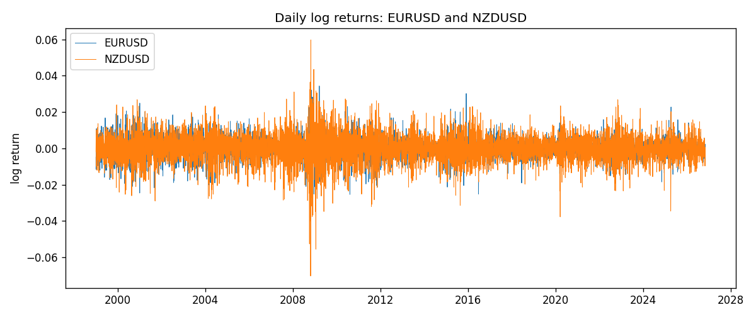
Log-return scatter
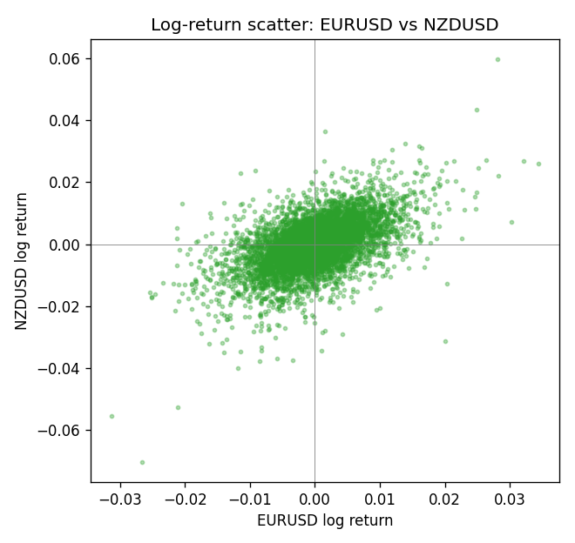
Rank-rank scatter
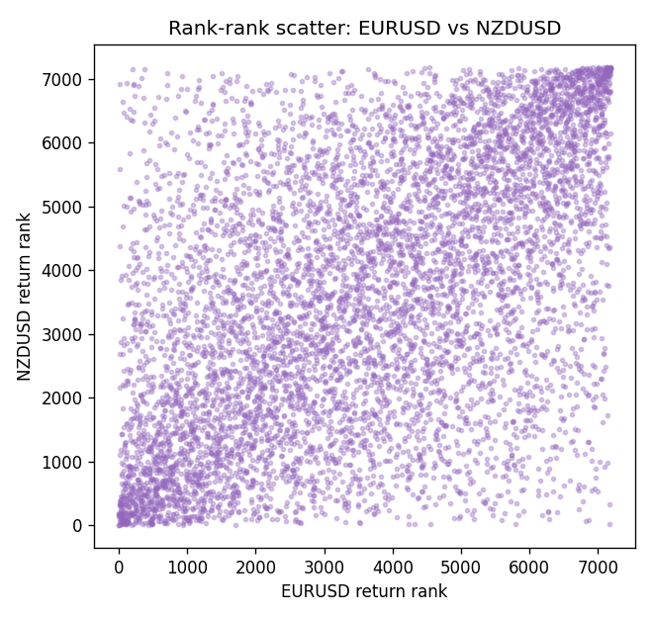

Data report
Every matched row that entered Spearman rho is stored in the sibling CSV named EURUSD-NZDUSD_Spearman_D1.csv. That file is the complete data archive for redrawing charts. Embedding all rows as a Word table is impractical at this length; the Word file holds the column list, column summaries, and the first and last 15 matched rows.
Columns: time, EURUSD_open, NZDUSD_open, EURUSD_high, NZDUSD_high, EURUSD_low, NZDUSD_low, EURUSD_close, NZDUSD_close, EURUSD_tick_volume, NZDUSD_tick_volume, EURUSD_spread, NZDUSD_spread, EURUSD_real_volume, NZDUSD_real_volume, EURUSD_log_return, NZDUSD_log_return
Column summaries (matched calculation rows)
column | count | mean | std | min | 25% | 50% | 75% | max
EURUSD_open | 7186 | 1.181357 | 0.15085833 | 0.8272 | 1.086165 | 1.16609 | 1.2939475 | 1.5995
NZDUSD_open | 7186 | 0.65641776 | 0.10819833 | 0.3913 | 0.59134 | 0.6684 | 0.7249075 | 0.88218
EURUSD_high | 7186 | 1.1864878 | 0.15145386 | 0.8326 | 1.09024 | 1.17121 | 1.2993075 | 1.6038
NZDUSD_high | 7186 | 0.66033433 | 0.10869188 | 0.3961 | 0.59475 | 0.67202 | 0.72936 | 0.88421
EURUSD_low | 7186 | 1.1763494 | 0.15017707 | 0.8227 | 1.082045 | 1.162475 | 1.2884175 | 1.5865
NZDUSD_low | 7186 | 0.65273031 | 0.10779283 | 0.3897 | 0.5880725 | 0.664185 | 0.720965 | 0.87988
EURUSD_close | 7186 | 1.1813978 | 0.15082738 | 0.8267 | 1.0860425 | 1.16602 | 1.2939725 | 1.5997
NZDUSD_close | 7186 | 0.65649194 | 0.10819527 | 0.3907 | 0.59159 | 0.66842 | 0.725015 | 0.8822
EURUSD_tick_volume | 7186 | 103205.25 | 173535.32 | 218 | 9413.25 | 52774.5 | 99579.75 | 1471626
NZDUSD_tick_volume | 7186 | 68709.014 | 123134.25 | 16 | 5585.5 | 33893.5 | 58510.5 | 1127682
EURUSD_spread | 7186 | 19.350682 | 16.562781 | 0 | 8 | 12 | 27.5 | 50
NZDUSD_spread | 7186 | 30.284303 | 25.649992 | 0 | 9 | 17 | 47.5 | 80
EURUSD_real_volume | 7186 | 4.0330482e+10 | 1.6691688e+11 | 0 | 0 | 0 | 0 | 3.6149665e+12
NZDUSD_real_volume | 7186 | 1.6701379e+10 | 8.497804e+10 | 0 | 0 | 0 | 0 | 2.705649e+12
EURUSD_log_return | 7186 | -4.99e-06 | 0.00579654 | -0.03123819 | -0.00323792 | 0 | 0.00325328 | 0.03433183
NZDUSD_log_return | 7186 | 9.3e-06 | 0.0076423 | -0.07027433 | -0.00425367 | 0.00022883 | 0.00457975 | 0.05966839
First 15 matched rows (selected columns)
time | EURUSD_close | NZDUSD_close | EURUSD_log_return | NZDUSD_log_return | EURUSD_tick_volume | NZDUSD_tick_volume
1999-01-05 | 1.1758 | 0.5372 | -0.0048360507 | -0.0018597736 | 4793 | 748
1999-01-06 | 1.1623 | 0.5383 | -0.011547966 | 0.0020455609 | 4828 | 823
1999-01-07 | 1.1712 | 0.5417 | 0.0076280636 | 0.0062963171 | 5076 | 878
1999-01-08 | 1.1585 | 0.5414 | -0.010902799 | -0.00055396548 | 5120 | 668
1999-01-11 | 1.1503 | 0.547 | -0.007103287 | 0.010290425 | 4960 | 681
1999-01-12 | 1.1555 | 0.5441 | 0.0045103728 | -0.0053157489 | 5248 | 793
1999-01-13 | 1.1681 | 0.5387 | 0.010845346 | -0.0099742238 | 6623 | 1050
1999-01-14 | 1.1681 | 0.5386 | 0 | -0.00018564931 | 5472 | 1137
1999-01-15 | 1.1563 | 0.5382 | -0.010153245 | -0.00074294208 | 6529 | 1124
1999-01-18 | 1.1605 | 0.5372 | 0.0036256946 | -0.0018597736 | 4054 | 1022
1999-01-19 | 1.1603 | 0.5382 | -0.00017235436 | 0.0018597736 | 5595 | 1389
1999-01-20 | 1.1566 | 0.5404 | -0.0031939256 | 0.0040793678 | 5736 | 1678
1999-01-21 | 1.1601 | 0.5426 | 0.0030215416 | 0.0040627941 | 5230 | 1599
1999-01-22 | 1.1587 | 0.5361 | -0.0012075213 | -0.012051689 | 4559 | 1328
1999-01-25 | 1.1552 | 0.5342 | -0.0030251979 | -0.0035504102 | 3774 | 1035
Last 15 matched rows (selected columns)
time | EURUSD_close | NZDUSD_close | EURUSD_log_return | NZDUSD_log_return | EURUSD_tick_volume | NZDUSD_tick_volume
2026-10-13 | 1.11965 | 0.56127 | 0.0037402957 | 0.0047326165 | 54238 | 27958
2026-10-14 | 1.11545 | 0.55918 | -0.0037582255 | -0.0037306483 | 62973 | 37319
2026-10-15 | 1.12172 | 0.56185 | 0.0056053107 | 0.0047634855 | 77110 | 43714
2026-10-16 | 1.12371 | 0.56509 | 0.0017724895 | 0.0057501001 | 61341 | 35806
2026-10-19 | 1.12086 | 0.56616 | -0.0025394633 | 0.0018917133 | 58324 | 32069
2026-10-20 | 1.12354 | 0.56827 | 0.0023881672 | 0.0037199341 | 52645 | 34470
2026-10-21 | 1.12318 | 0.57003 | -0.00032046717 | 0.0030923331 | 49937 | 30020
2026-10-22 | 1.12139 | 0.56815 | -0.0015949606 | -0.0033035227 | 60304 | 39159
2026-10-23 | 1.11989 | 0.56991 | -0.001338521 | 0.0030929853 | 56197 | 33693
2026-10-26 | 1.11735 | 0.56826 | -0.0022706559 | -0.0028993932 | 52040 | 30716
2026-10-27 | 1.11272 | 0.56811 | -0.004152342 | -0.00026399852 | 56245 | 32660
2026-10-28 | 1.1152 | 0.56261 | 0.0022262927 | -0.0097283914 | 61037 | 42740
2026-10-29 | 1.11772 | 0.56296 | 0.0022571351 | 0.00062190714 | 73892 | 40247
2026-10-30 | 1.11644 | 0.56307 | -0.0011458446 | 0.00019537668 | 70119 | 39305
2026-11-02 | 1.11881 | 0.56161 | 0.002120569 | -0.0025962955 | 59416 | 35347

